# Matter

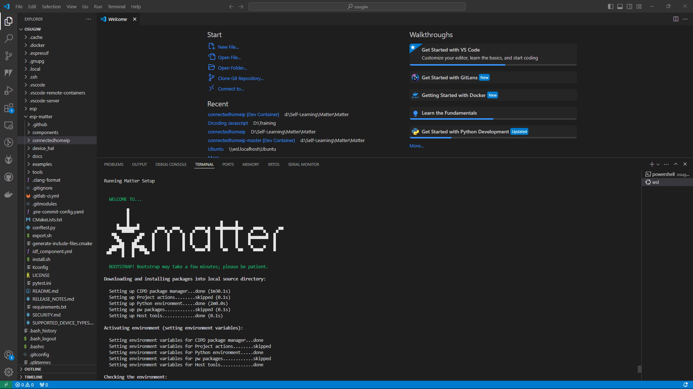

## Data Model

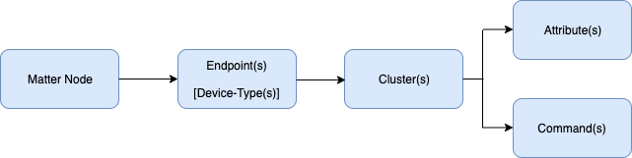

* **Node** – Unique network address that expose some functionality. Commonly, it refers to physical device.
* **Endpoint** – It is a virtual device that provides services that could be logically grouped together. Each Matter Node can have several endpoints. The Matter specification defines certain common Device Types. While endpoint 0 is reserved, it contains certain services that are applicable to the entire node. It also known as *root node* device type and the clusters inside this endpoint include:
  + Basic Information Cluster Server – Information including node, firmware version, manufacturer, etc.
  + ACL Cluster Server – Allow configuration of the Access Control Lists for this node.
  + Network Commissioning Cluster Server – Allows configuration of a network (Wi-Fi, Ethernet, Thread) on the node.
* **Clusters** – A group that has common function. An endpoint can have several clusters.
* **Attributes** – Cluster data.
* **Commands** – Set of command that can be used for triggering a specific behaviour.

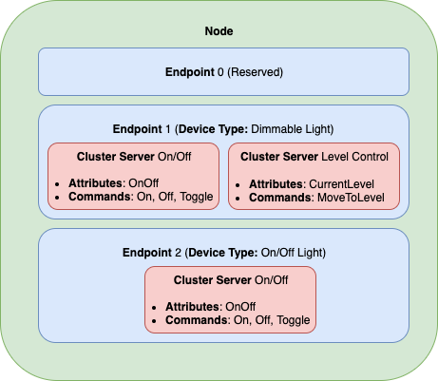

## Cluster Servers and Clients

In every Matter cluster has a **Cluster server** and a **Cluster Client counterpart**.

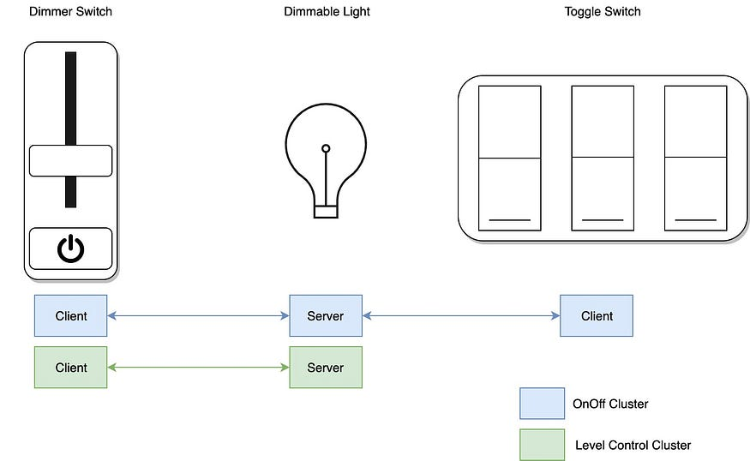

## Device-to-Device Automations

As the Matter Cluster has servers and clients, they can be configured to communicate with a specific device when certain conditions is met. This can be achieved through **Device Binding,** a Matter phone application can establish binding between devices, even though they are not from same vendors.

### Synchronous Control

It requires a Binding cluster server that offers the binding service.

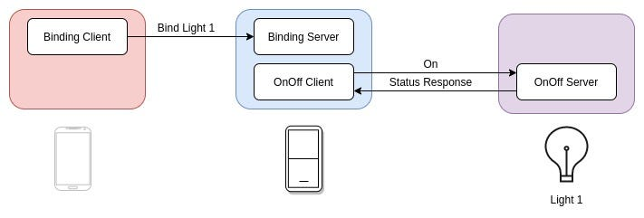

### Asynchronous Notification (Subscribe-Report)

It has two roles: subscriber and publisher, a device can subscribe to attributes and/or events (every single change) on the publisher. After successfully bind, the publisher will periodically send data to the subscriber.

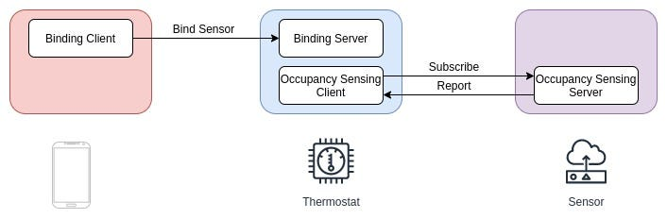

## Matter Bridge between Matter and non-Matter Device

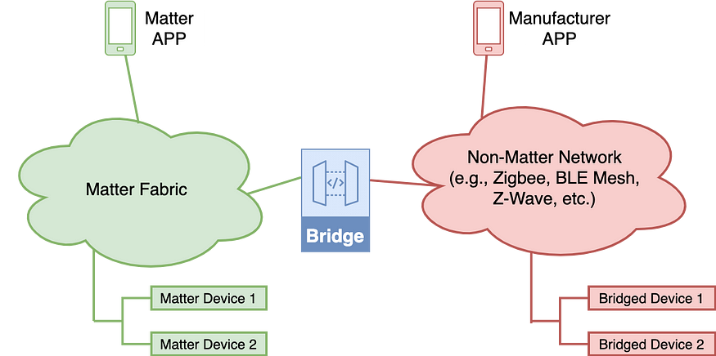

A Bridge allows non-Matter device (BLE, Wi-Fi, Zigbee, etc.) to join the Matter ecosystem (Matter Fabric) and communicate with Matter devices. A bridge device has some additional data parameters on each cluster, namely **Descriptor**. A descriptor on endpoint 0 has different information, it has *PartList Field* that tells all the endpoints for bridged devices and each endpoint in non-Matter devices represent one device. The native Matter functionality may also be implemented on a bridge device that have multiple communication protocols (i.e. Wi-Fi and 802.15.4.).

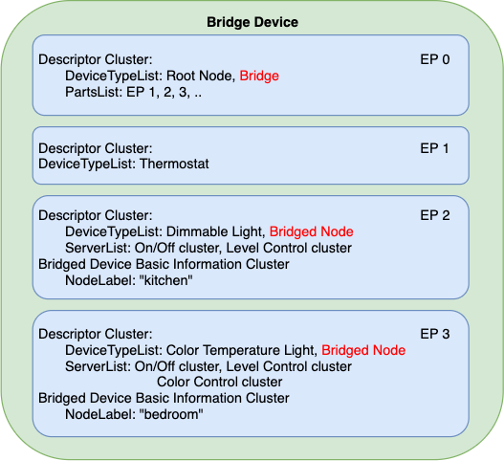

Here is the example on how to control a Zigbee device using Matter protocol:

1. The Bridge device follow the standard Matter commissioning process to join the Matter fabric.
2. The Matter-Zigbee Bridge Device join the Zigbee network.
3. Once the Bridge Device joins the Zigbee network, the Matter-Zigbee Bridge device can discover the supported devices in the Zigbee network by broadcasting the **Match Descriptor request** command (including: desired profile, in- and out-clusters). Then the corresponding Zigbee devices will reply the **Match Descriptor Response** with its network address included.
4. The Bridge exposes all the Bridged Devices to the Matter Fabric.
5. The controllers in the Matter fabric can control the lights in the Zigbee network with the help of Bridge.

# Rainmaker

Claiming device certificates using **Host driven claiming**.

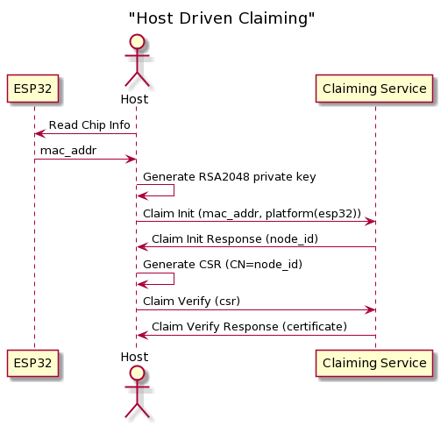

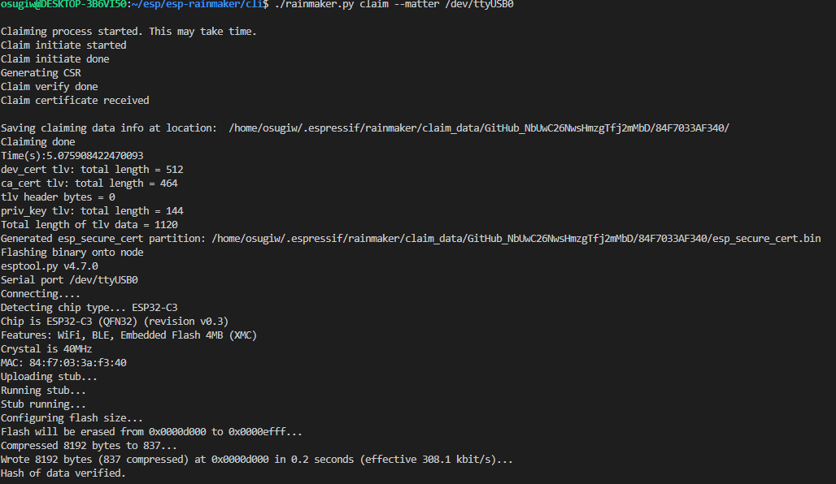

Generating the factory NVS binary using *mfg_tool* of esp_matter SDK.

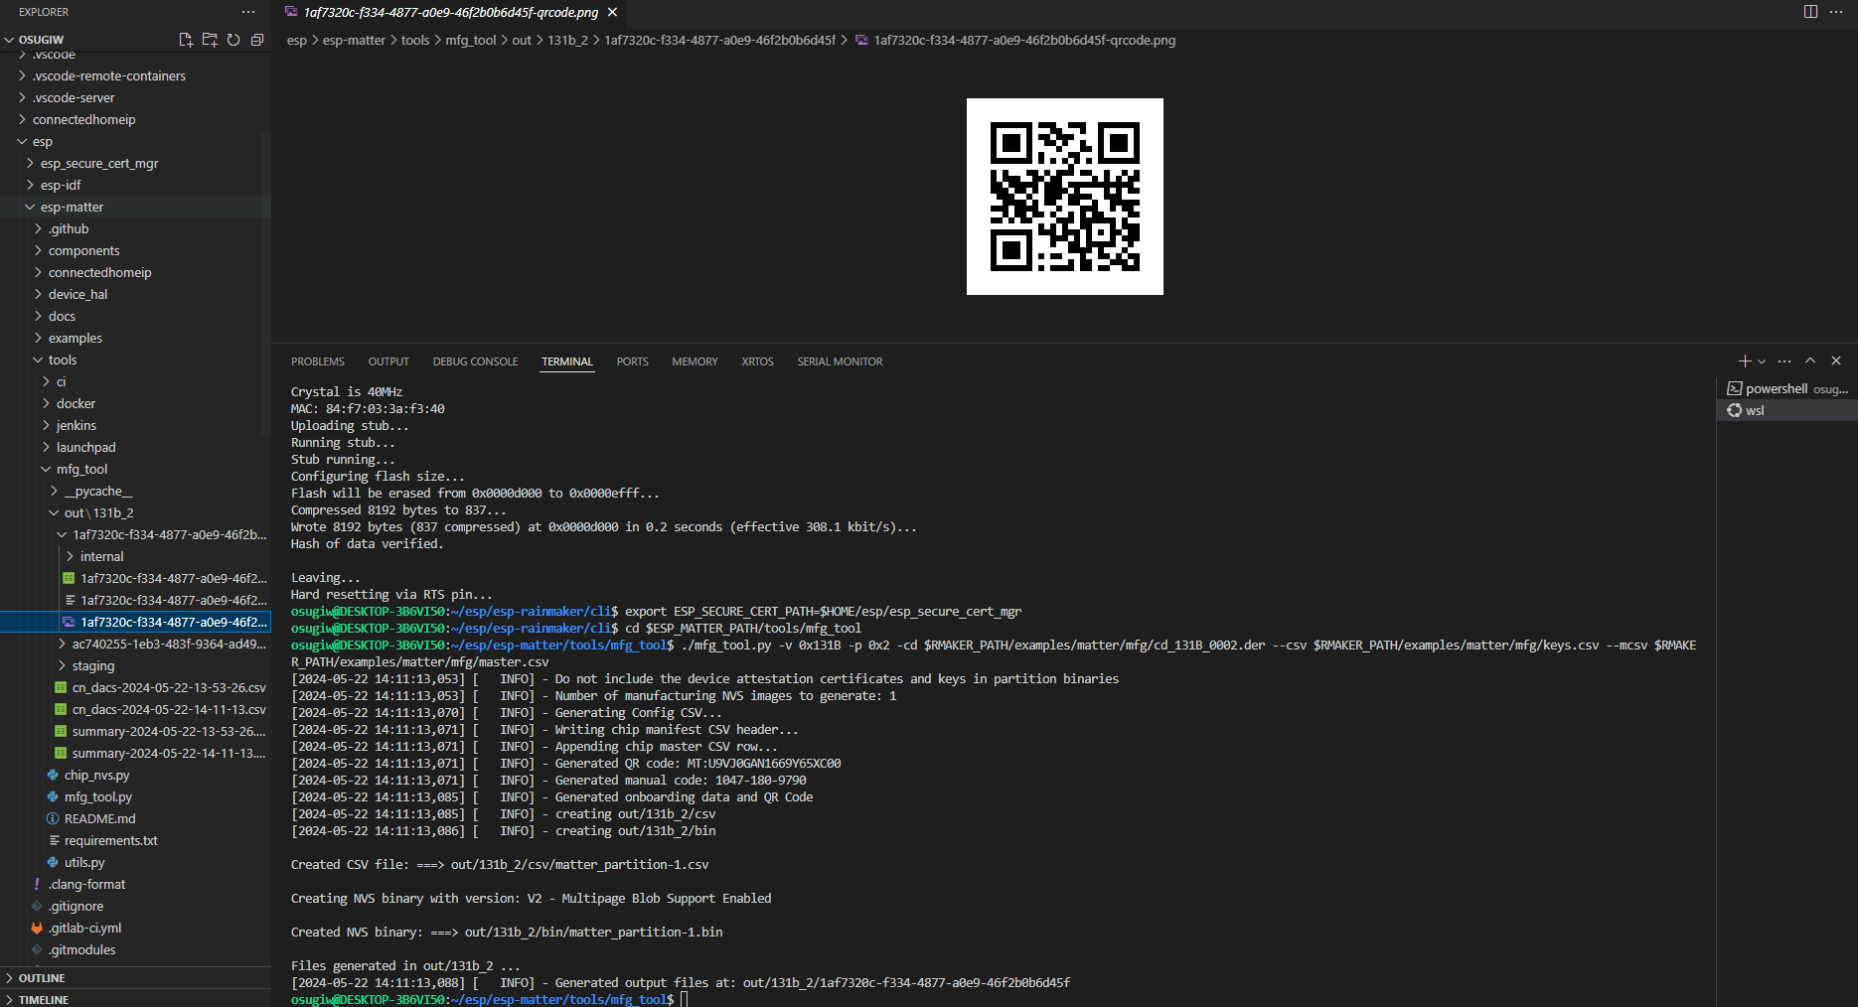

The factory binary generated above should be flashed onto the fctry partition (default : 0x3fa000 for ESP32-C6 and 0x3e0000 for other chips).

After being connected to the same WiFi network then the device will bring up the Matter configurations.

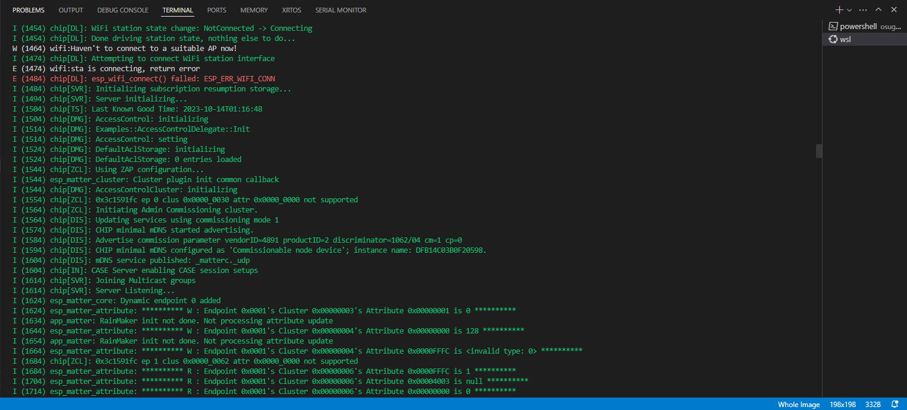

Create the Matter environments (Matter Fabric)

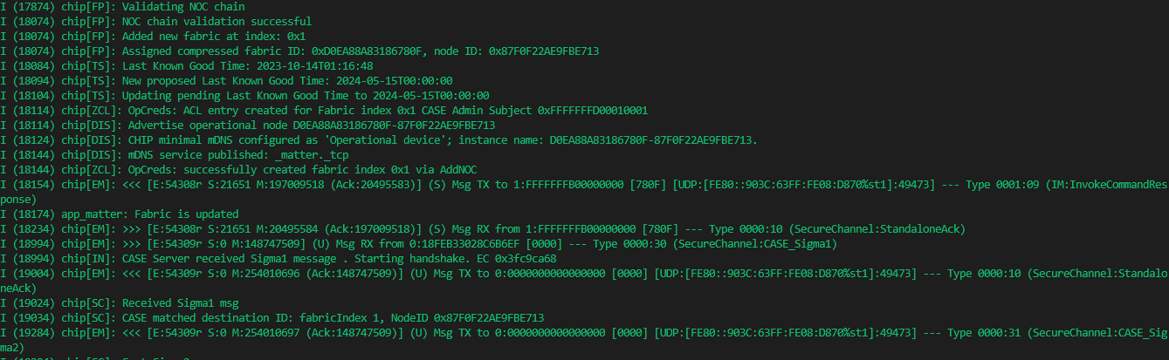

Commission the Matter device using the ESP-Rainmaker application by scanning the generated QR Code.

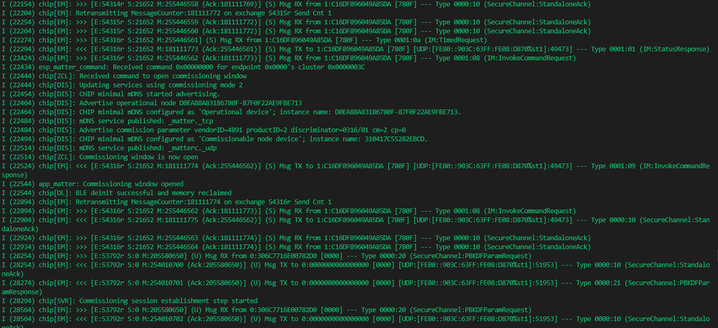

# References

1. [esp-rainmaker/examples/matter at master · espressif/esp-rainmaker (github.com)](https://github.com/espressif/esp-rainmaker/tree/master/examples/matter)